LENS ABERRATIONS – COMA ABERRATIONS

Aberrations : Defects in Images

Defects in images formed due to defective lens are called as aberrations
Due to the defects in lens the size, shape or the position of the image may vary.

Lens aberrations are of two types

- Chromatic

- Monochromatic

Chromatic aberrations: Arises when white light ( multi wavelegths - 7) is used as a source.

Monochromatic aberration: Arises even when light of single colour (Wave length) is
used

Monochromatic aberration is of five types

1. SPHERICAL ABERRATION

2.COMA

3.ASTIGMATISM

4.CURVATURE

5.DISTORTION

COMA ABERRATION

Arises due to Rays from an off-axis point

Creates a trailing "comet-like" blur directed away from the optic axis

Produces a sharp image in the center of the field, but becomes increasingly blurred toward the edges.

The resulting image is called a comatic circle

DETAILED EXPLANATION:

When the point object is situated slightly off the axis the image of the point object formed by the lens is found to have an egg like shape, this defect in the image is called coma

Consider an off axial point A in the object OA as shown in the figure

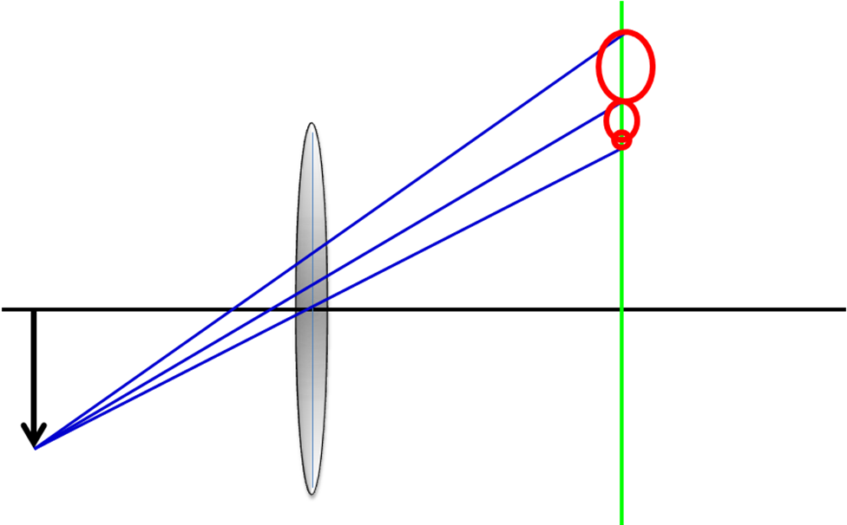

Let the length be divided into different zones.
Consider the image of point A formed by the different zones of the lens formed by different zones of the lens.

The rays leaving the point A and passing through different zones of the lens are brought to focus at different points as shown in the figure.
The image is not in a perfect focus, this defect is known as Coma

COMMA ARISES DUE TO DIFFERENT REASONS

- Different zones of the lens produce different lateral magnification
Due to this, the rate starting from point A and passing through different zones of the lens focus at different points.

- Each zone forms the image of a point in the form of a circle
Consider a particular zone of the lens as shown in figure

let the zone have points of diametrically opposite points.
These points form a circle called comatic circle. The radius of the chromatic circle increases as the radius of the zone of the lens increases.

The resultant image is comet like.

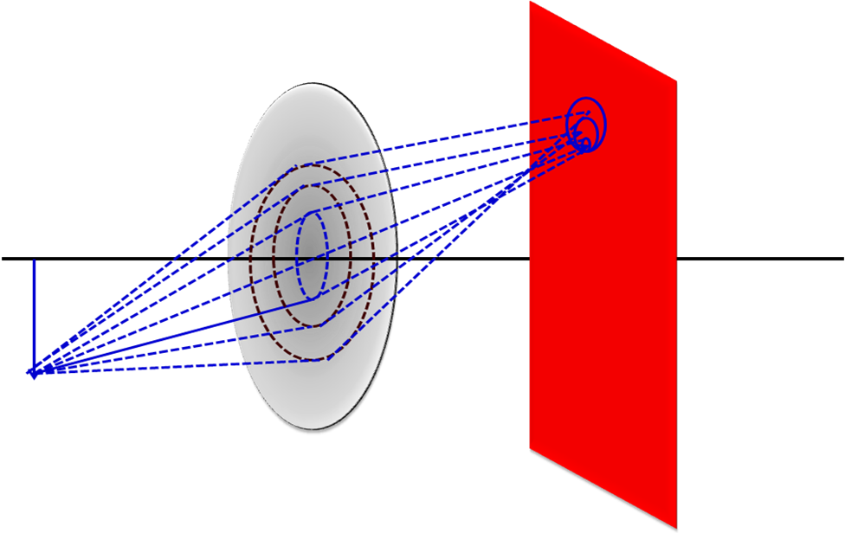
ELLIMINATION OF COMA

- Use of stops

- Designing lens of suitable shapes and sizes

- Following Abbe Sine condition μ₁ y₁ sinθ ₁ = μ₂ y₂ sinθ ₂

ASTIGMATISM

when a point object is situated far off the axis of a lens , the image formed by the lens is not in a perfect focus.
The image consists of two mutually perpendicular lines separated by a finite distance.
The two lines line in perpendicular planes

This defect of the images called as astigmatism.

The astigmatism is shown in figure.

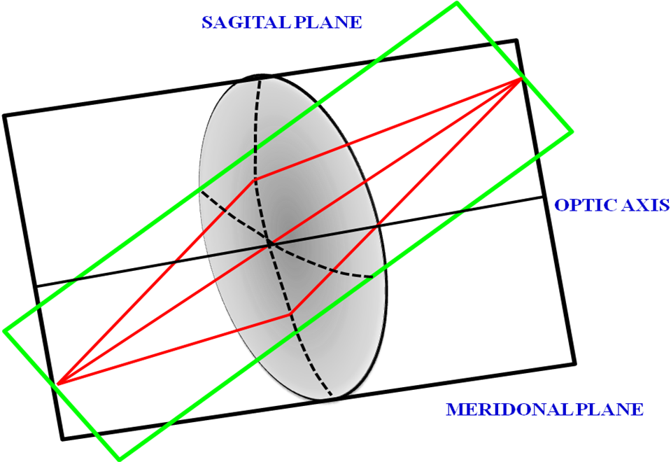

O is a point object situated far off from the axis of the lens.

Meridonal plane is shown in black colour, and green colour plane is the Sagittal plane

The screen is moved between M and S an irregular patch of light is obtained This patch of light reduces to a circle known as circle of least confusion
The difference between the lines M and S is a measure of astigmatism and is called astigmatic difference

Astigmatism occurs when rays travelling along two planes that are perpendicular to each other have different image distances for a sharp focus.

This means that if the image of a cross is viewed, the vertical and horizontal lines will be in sharp focus at two different distances from the eye.

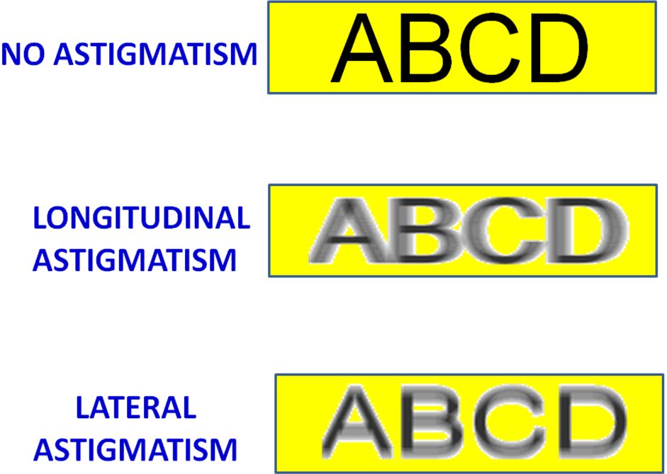

MINIMIZATION OF ASTIGMATISM

- Stops

- Convex and Concave lenses separated by distance

- Adjusting the positions between a system of lenses

